Encryption For API

In the sample demo we have used below files,

- NetworkUtility.java – It is used to check network connection status using ConnectivityManager and NetworkInfo.
- EncryptionUtility.java – It is used to encrypt and decrypt messages using AES 256 bit encryption.
- OKHTTPService.javba – It is used to get and post service response to server using okhttp.
- FamilyProfileService.java – It is an AsyncTask class for calling webservice managing UI and background thread.
- MainActivity.java – It is the activity class for taking inputs and display result.

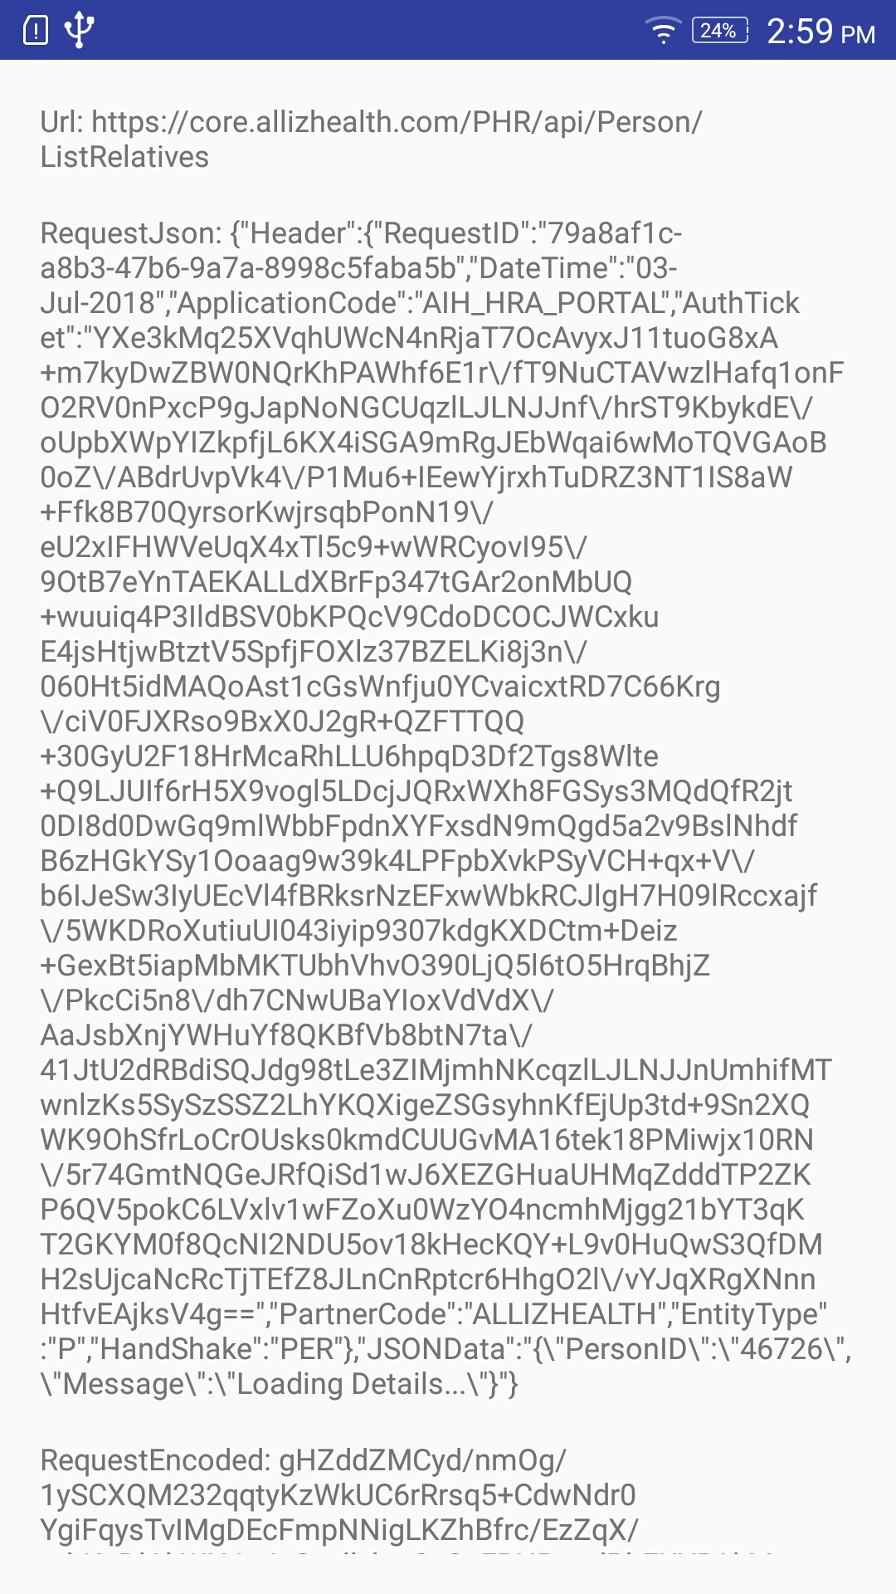
Description – Here, we use below sample url to retrive family profile details,

String strUrl ="https://core.allizhealth.com/PHR/api/Person/ListRelatives";

We have below json data that needs to be encrpted,

String strJsonData="{\"Header\":{\"RequestID\":\"79a8af1c-a8b3-47b6-9a7a-8998c5faba5b\",\"DateTime\":\"03-Jul-2018\",\"ApplicationCode\":\"AIH_HRA_PORTAL\",\"AuthTicket\":\"YXe3kMq25XVqhUWcN4nRjaT7OcAvyxJ11tuoG8xA+m7kyDwZBW0NQrKhPAWhf6E1r\\/fT9NuCTAVwzlHafq1onFO2RV0nPxcP9gJapNoNGCUqzlLJLNJJnf\\/hrST9KbykdE\\/oUpbXWpYIZkpfjL6KX4iSGA9mRgJEbWqai6wMoTQVGAoB0oZ\\/ABdrUvpVk4\\/P1Mu6+IEewYjrxhTuDRZ3NT1IS8aW+Ffk8B70QyrsorKwjrsqbPonN19\\/eU2xIFHWVeUqX4xTl5c9+wWRCyovI95\\/9OtB7eYnTAEKALLdXBrFp347tGAr2onMbUQ+wuuiq4P3IldBSV0bKPQcV9CdoDCOCJWCxkuE4jsHtjwBtztV5SpfjFOXlz37BZELKi8j3n\\/060Ht5idMAQoAst1cGsWnfju0YCvaicxtRD7C66Krg\\/ciV0FJXRso9BxX0J2gR+QZFTTQQ+30GyU2F18HrMcaRhLLU6hpqD3Df2Tgs8Wlte+Q9LJUIf6rH5X9vogl5LDcjJQRxWXh8FGSys3MQdQfR2jt0DI8d0DwGq9mlWbbFpdnXYFxsdN9mQgd5a2v9BslNhdfB6zHGkYSy1Ooaag9w39k4LPFpbXvkPSyVCH+qx+V\\/b6IJeSw3IyUEcVl4fBRksrNzEFxwWbkRCJlgH7H09lRccxajf\\/5WKDRoXutiuUI043iyip9307kdgKXDCtm+Deiz+GexBt5iapMbMKTUbhVhvO390LjQ5l6tO5HrqBhjZ\\/PkcCi5n8\\/dh7CNwUBaYIoxVdVdX\\/AaJsbXnjYWHuYf8QKBfVb8btN7ta\\/41JtU2dRBdiSQJdg98tLe3ZIMjmhNKcqzlLJLNJJnUmhifMTwnlzKs5SySzSSZ2LhYKQXigeZSGsyhnKfEjUp3td+9Sn2XQWK9OhSfrLoCrOUsks0kmdCUUGvMA16tek18PMiwjx10RN\\/5r74GmtNQGeJRfQiSd1wJ6XEZGHuaUHMqZdddTP2ZKP6QV5pokC6LVxlv1wFZoXu0WzYO4ncmhMjgg21bYT3qKT2GKYM0f8QcNI2NDU5ov18kHecKQY+L9v0HuQwS3QfDMH2sUjcaNcRcTjTEfZ8JLnCnRptcr6HhgO2l\\/vYJqXRgXNnnHtfvEAjksV4g==\",\"PartnerCode\":\"ALLIZHEALTH\",\"EntityType\":\"P\",\"HandShake\":\"PER\"},\"JSONData\":\"{\\\"PersonID\\\":\\\"46726\\\",\\\"Message\\\":\\\"Loading Details...\\\"}\"}";

We use OKHttp for webservice calls. Encryption class has encrypt method that is used to encrypt the jsondata with “AES” Mode passed to the SecretKeySpec class.

This encrpted string is sent to server as a request.
String strEncodedRequest = EncryptionUtility.encrypt("A1HS8CUR1TY@9812",strJson, "A1HS8CUR1TY@9812");
System.out.println("OkHttp get EncodedRequest: " + strEncodedRequest);
RequestBody body = RequestBody.create(JSON, strEncodedRequest);
After we receive response, we get encoded string as response.

Then we use Encryption class for decrypt method that is used to decrypt the string with “AES” Mode to jsondata.

Finally, we have expected result data in form of json string.

